**FABRIC AND WINDOW TREATMENTS**

**IDEC1045**

**Week 5, Linings and Window Treatment Styles**

1. Replace the highlighted areas above.
2. Fill in the cells on the right in the table below.

## Week at a Glance

|  |  |
| --- | --- |
| **Week at a Glance** | |
| This week’s course learning outcomes (number and text) | **CLO02:** Evaluate fabric construction that includes weaves yarns and durability for various window treatment needs.  **CLO03:** Explain fabric and drapery terminology, dye lot differences, pattern repeat railroading and common care codes for cleaning and maintaining materials.  **CLO04:** Outline current fabric trends including pattern, texture and styles as well as uses and benefits of linings to create quality window treatments for various uses |
| This week’s unit learning outcomes (number and text) | **Text:** Designing Interiors 2nd pages 471-474 (window types)  **Unit 3:**  3.1 define what lining is and how it is used.  3.2 Identify different types of lining such as cotton/poly  3.3 Examine lining qualities  3.4 Recognize the importance of lining to success of drapery appearance and durability.  **Unit 4:**  4.1 Describe various drapery styles, such as stationary side panels and operating drapery as well as shades and valances  4.2 define various drapery styles and the décor styles they can be used with  4.3 Identify various pleat styles and drapery hanging heights used in today’s decorating market  4.4 Compare differences in ready-made and custom treatment quality and their cost differences. |
|  | |
| This week’s problem | This week’s problem is to explain some of the styles of window treatments on today’s market, what styles they are suited to and to learn about the importance of lining in fabric treatments. |
| How does this week’s problem fit into the course so far? | This week is a continuation of information for the student to understand and consider when planning any window treatment. There is a lot to know about this topic and each week more information is added for the student to absorb so that when they do start planning a treatment they have all the information required to complete a suitable and quality product. |
| List of topics and subtopics that will be covered to address this week’s problem | **Linings:** Importance of lining, different fabric content, various lining uses, lining types such as regular lining, blackout, interlining, thermal and discreet.  **Drapery styles:** stationary and operating drapery, shades and valances, Decorating styles of drapery, Drapery pleat styles, drapery lengths  **Window types:** Textpages 471 – 474. Considerations of function between treatment and window type.  **Custom versus ready-made drapery:**  Quality and cost differences, pros and cons. |
| If this is a hybrid course, what topics and activities will be covered in-class to support the online content? |  |
| How does problem fit into the remaining weeks of the course? |  |
|  | |
| Graded Assessment? | Yes. Fill out the Evaluation section below.  No. |

## Introduction

|  |  |
| --- | --- |
| **se** | |
| Introduction | Description of content for this week:   * Explain what the user will learn * Describe the problem the user will be able to solve by the end of week * Answer the question “What’s in it for me (the learner)?”   Now that you have learned some of the basics of fabric construction, weaves and patterns we will now look at how to apply them to window treatments. This week we will learn about fabric linings, their benefits and the kinds of lining selections are on the market for residential use. We will also look at some of the window styles in today’s homes and some of the styles of window treatments that suit various decorating styles. This information will prepare you to select the appropriate style to suit both the window design and the decorating style you want to use. At the end of this week you will be prepared to get into more detail about planning a suitable treatment for a home. |
|  | Write out the week’s unit learning outcomes here (number and text).  **Text:** Designing Interiors 2nd, 471-474 (window types)  **Unit 3:**  3.1 define what lining is and how it is used.  3.2 Identify different types of lining such as cotton/poly  3.3 Examine lining qualities  3.4 Recognize the importance of lining to success of drapery appearance and durability.  **Unit 4:**  4.1 Describe various drapery styles, such as stationary side panels and operating drapery as well as shades and valances  4.2 Define various drapery styles and the décor styles they can be used with  4.3 Identify various pleat styles and drapery hanging heights used in today’s decorating market  4.4 Compare differences in ready-made and custom treatment quality and their cost differences. |
| Other relevant announcements/ reminders | Insert notes on assignments and/or anything out of the ordinary.  Note: You can also add an image here for a front cover page look and feel.  Istock id: 175598293  C:\Users\Linda\Downloads\175598293.jpg |

****************** Beginning of instructional content ************************

Linings:

Many centuries past, lined drapery was the first form of insulation and some security in homes. In the middle ages homes often had windows that were slits in walls and no glass windows so these holes were covered with oiled linen and cloths to keep out the cold and elements. They also provided an aesthetic improvement to a dwelling if they could afford an attractive fabric. This kind of covering gave more privacy to homes as people could not look in from outside.

We have come a long way since then and yet linings still play an important role in window treatments.

### The Importance of lining

Linings today is the fabric sewn to the back of a face fabric like drapery and valances and fabric blinds.

Linings serve several functions on a window treatment such as…

1. Protects the face fabric from fading and sun damage

2. Allows the fabric pattern to between fully indoors without the sun shining through

3. Protects the fabric from moisture damage due to window condensation

4. Provides insulation in both summer and winter

5. Helps reduce noise from outside

6. Correct lining makes treatment hang better.

7. Creates body and adds fullness and richness to the treatment

8. Improves shape retention of the fabric and helps to reduce wrinkling

9. Provide a more uniform look from the outside of the home

10. Can visually enlarge the size of a window as the lining prevents being able to see where the window begins and ends.

11. Considerably extends the life span of the face fabric.

Linings are essentially the support system for the face fabric just like a box spring is the support system for a mattress or a primer is the basis for a quality paint job on walls.

Linings are always used by decorators for custom window treatments to provide the client with a quality, long lasting and beautiful treatment. There are several kinds of linings and a decorator should be aware of the kinds of linings, their widths and how to use them to provide the proper use and value to a treatment. It is important to use the correct kind of lining or linings to give the proper function and aesthetic quality to the treatment.

### Types of lining:

Linings come in several fiber types from synthetic to natural and blended. They also come in several quality from light weight to heavy weight yet are still lighter weight than the decorating face fabric.

A good lining can make an inexpensive and flimsy fabric look rich, while a poor lining can ruin the effect of a high end fabric.

Always use a good quality lining to get the best results.

**Residential lining** is what is typically used for homes. It is usually uncoated goods that offers water repellency, insulation value, stain resistance and ultraviolet inhibitors. It can range from 100% cotton to polyester/cotton blend, to 100% polyester. Some rayon and acetate linings are treated for flame resistance. Many can also come with a layer of foam acrylic for additional insulation. Medium weight linings can be used for any fabric weight in general.

Linings will come in glossy or matte finish which is a personal choice and in white or off white colouring.

Some of these linings will be described in more detail below.

**Commercial lining** must be used for hotels, businesses and hospitals. The lining must meet certain criteria such as flame retardants. There are special linings for these purposes, however we will be learning about residential linings only.

**Some tips for residential linings:**

* A lining should be non-stretch and also match the cleaning and care code of the face fabric. For example if you are planning a window treatment for a room that would need washing, the lining should also be washable. This happens frequently when matching a window treatment with a duvet or bedspread. Bedding gets washed regularly and the bedding lining must be compatible. If your fabric needs to be dry cleaned then you should select a lining that has the same cleaning code allowances or you may have a lining that can shrink making the face fabric pucker.
* If you are using a lining on a kitchen window or other stain and water susceptible location, use a stain-resistant finish to the lining. This will also protect against mildew, discolororing and setting of oil-borne stains.
* If your face fabric is prone to wrinkling it is best to use a high thread count lining that will give more support to the face fabric.
* Some face fabrics can be very heavy especially if they are operating and require a lot of yardage and so a quality light lining with a high thread count would prevent the entire treatment from becoming heavy enough as to pull the brackets off the wall.

**Blackout lining:**

Blackout lining is a special kind of lining to improve light control coming into a room. There are levels of blackout from what is called dim out which blocks most of the light to full blackout which blocks almost all light. Some use an acrylic foam coating for improved insulation and noise control. While regular lining will block out about 50% of light, a full blackout will block about 95% of light coming into a room when the treatment is closed.

Some of these linings also are treated to repel water and prevent staining. The added insulation is good for older homes or cold climates and can be a cost savings on utilities.

Blackout lining is good for bedrooms where small children take day time naps and for shift workers who sleep during the day while others need total darkness to sleep at night as well and so blackout lining will help with this need.

Some blackout linings can be very stiff and heavy and do not drape well so it is important to choose one that is soft for better pleating and hang effects. I use ones that are called 2 or 3 (layers) pass blackout linings which have a thin layer of black fabric between white and are very soft to the touch and drape well.

This is a good video about blackout lining…

<https://www.youtube.com/watch?v=6sTf1FgAxYo>

By Linda Guthro

This shows a 2 pass blackout lining back and the information on the fabric back

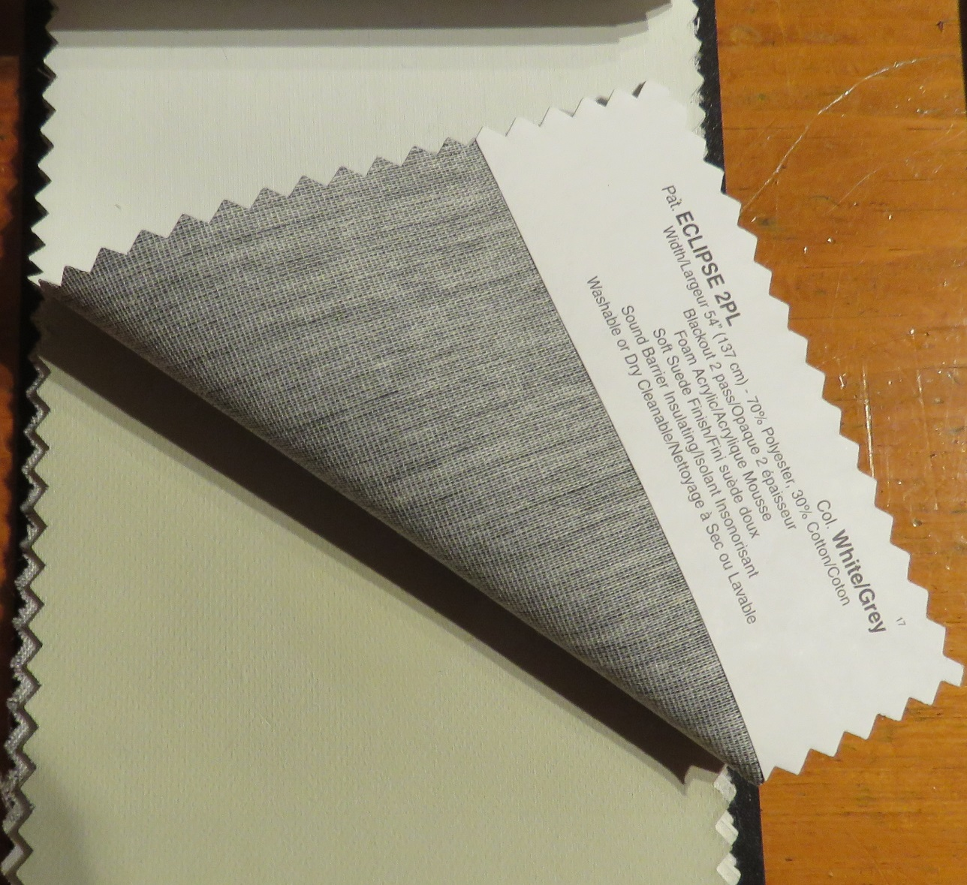

**Interlining:**

Interlining is a kind of lining that is placed between the regular lining and the face fabric meaning that there are two kinds of lining on a treatment. The content is almost always cotton and looks like a light weight flannel. This kind of lining reduces sound, is a good insulator and blocks light from shining through a fabric. In a previous lesson I mentioned that silk will rot easily when exposed to sunlight. An interlining or a blackout lining is needed with this fabric to protect it from the sun to avoid the fabric from rotting. Interlining is also used to give body to a treatment and allows the drape of a fabric to be softer. I personally love using interlining to give a full and rich look to a treatment. I always use an interlining for a valance or shade to give the fabric more support and body. It is amazing the difference an interlining can make to the treatment and produce a very professional appearance.

Bump cloth is an English interlining that is heavier than a standard interlining.

By Linda Guthro

This is a standard interlining and the one I like to use most.

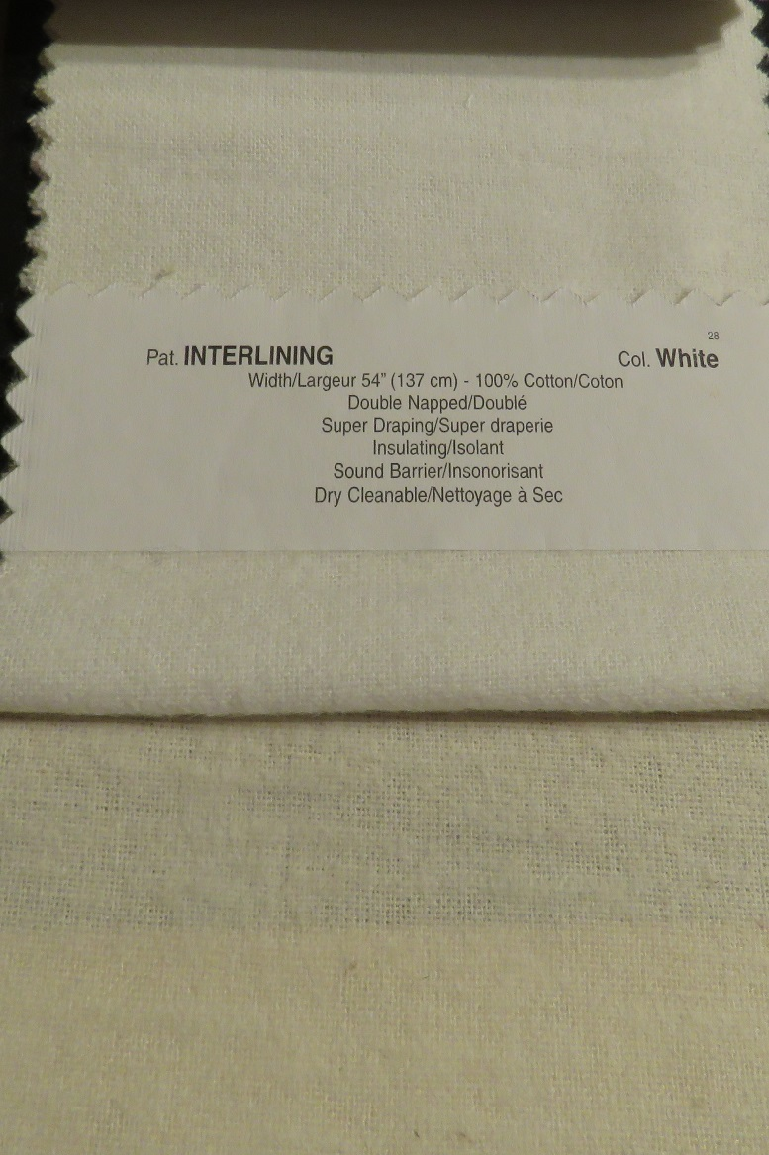

By Linda Guthro

The bump cloth on the left is much heavier and thicker than the regular interlining on the right

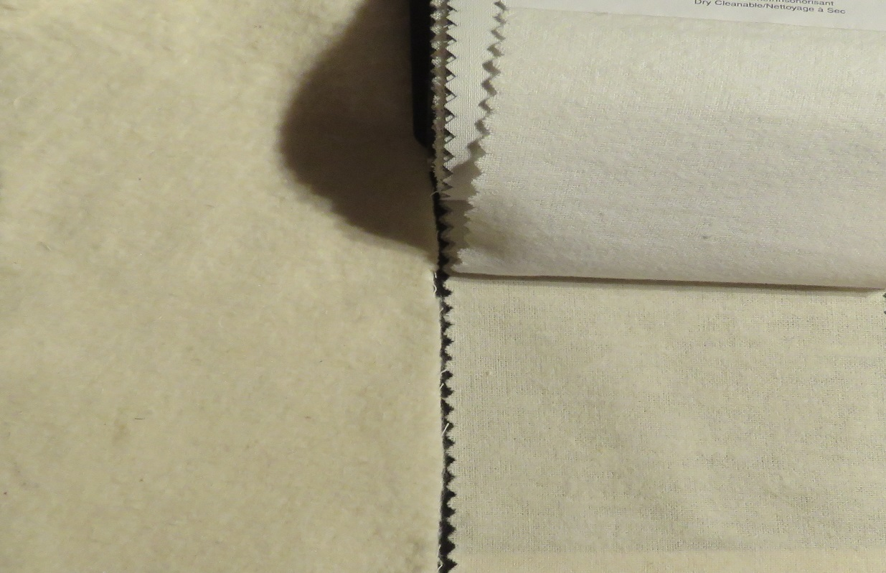

**Thermal lining:**

A thermal lining is one that has a layer of foam attached to the back of the face fabric. It helps to keep the room warm in winter and cool in summer. It helps the “R” value of windows by creating an air pocket between the window and the treatment that allows heating and air conditioning to be more efficient. It can also give some ultraviolet resistance to the fabric.

**Discreet lining:**

Most linings are not intended to be an obvious decorative feature and are not seen inside the room but only seen from the outside of the home. A discreet lining is when the reverse side of a drape or other treatment is folded back so that one sees the back of the drape in a matching or coordinating fabric to the face fabric. This fabric is not a real lining but an actual fabric that is visible in the room. This treatment requires an interlining to give body and some light protection to the face fabric, however be aware that the discreet fabric used for a visible lining will fade and be affected by the sunlight hitting it.

Istock id: 471133265

Notice in this photo how you can see a coordinating fabric on the backside of this treatment that is called a discreet lining.



**Interesting note**: All decorators find a lining they prefer to use. I have two that I prefer to use and buy by the bolt to save on the cost. I like a cotton/poly blend, medium weight and washable as my basic lining. I also use an interlining for certain treatments and a thermal lining on occasion for added insulation. I recommend you do your research and find the lining you prefer to use as well.

These are two company websites that carry good linings...

<https://www.bournemills.ca/>

<http://www.alendelfabrics.com/lining-2/>

This is an interesting site describing interlinings…

<http://www.sartorialsoftfurnishings.co.uk/interlining/>

This video talks about linings in general…

<https://www.youtube.com/watch?v=OM8m0Qb-_fY>

Drapery styles:

### Pleat styles:

There are many kind of pleat styles for window treatments and I will describe some of the most popular here. Each have their own look and offer the decorator many looks to use for clients.

**1. Pinch pleat** is sometimes known as a French pleat is the most common traditional kind of pleat. This pleat can be used for all styles except for ultra-modern. Pleats are often folded 3 times however there are varying styles of this pleat in drapery books to give you more individual ideas.

Istock id: 184871344

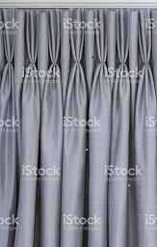

**2. Goblet pleat**

The goblet pleat is very similar to the pinch pleat and is actually made the same way. The difference is instead of showing the 3 prongs of the pleat, the pleat is pushed out and rounded like a goblet to create a soft curve and a more feminine appearance. This is a great traditional look.

Istock id: 155357066

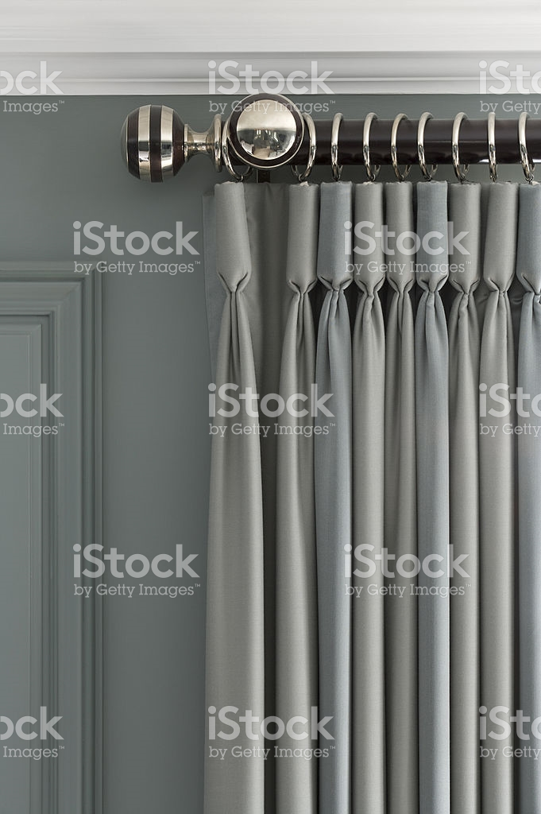

**3. Cinch pleat (Parisian or European)**

This pleat style is a more modern pleat style where the pleat starts at the very top of the treatment and gives the treatment great folds and a fuller look. For this treatment you must use a decorative rod. This is a wonderful pleat style for all styles.

Istock id: I cannot find a photo of this

Photo I have here is not copyright okay as an example of what to look for

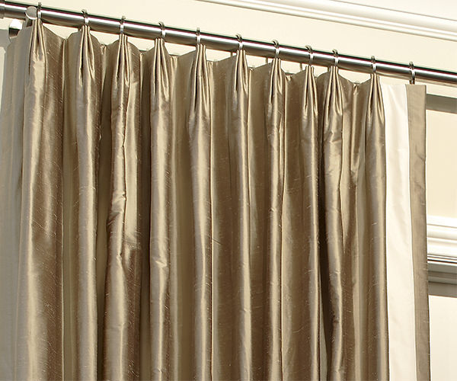

**4. Ring top pleat**

The ring top pleat is a treatment that has no structured pleating but at uniform spacing across the top, rings are clipped or attached to the back of a flat fabric so that when they are gathered they form pleats. This treatment is able to be used for all styles of décor.

Istock id: 171112016

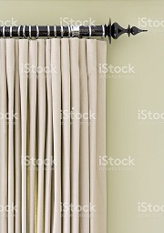

**5. Tab and tie top pleat**

Tab and tie top pleating is using a fabric band at the top of a flat fabric that when gathered creates casual folds. This kind of pleat is not meant to operate but should only be used for stationary treatments as the tab or tie will not lay evenly on the rod when moved. It is mostly used for more causal styles like urban country, or a casual traditional style but is not recommended for more contemporary styles.

Istock id: 185254530

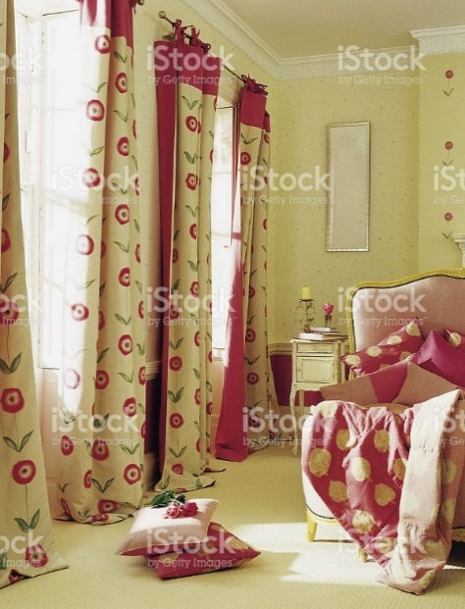

**6. Grommet pleat**

The grommet pleat is very popular for many styles using a ring called a grommet 1 inch down from the top of the treatment and actually cut into the fabric. The treatment easily slides on a rod to create folds. This style can be used for all styles except for very formal looks.

Istock id: 532410064

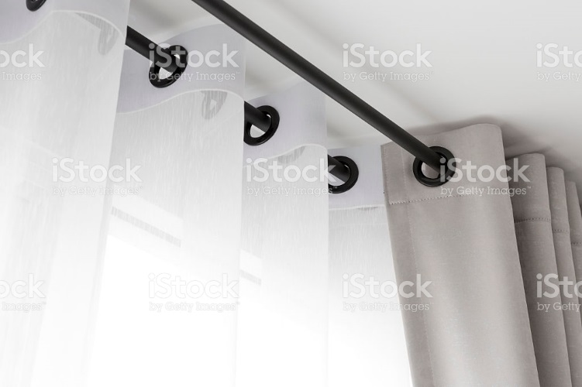

**7. Pocket pleat**

A pocket pleat is when a fabric is gathered to make a hole or pocket for the rod to pass through. When the fabric is gathered it creates the pleats. This can have fabric above the pocket to create a ruffle for more country looks or can have the pocket with no ruffle for use in rather casual use of style from traditional to casual contemporary.

Istock id: 187972720

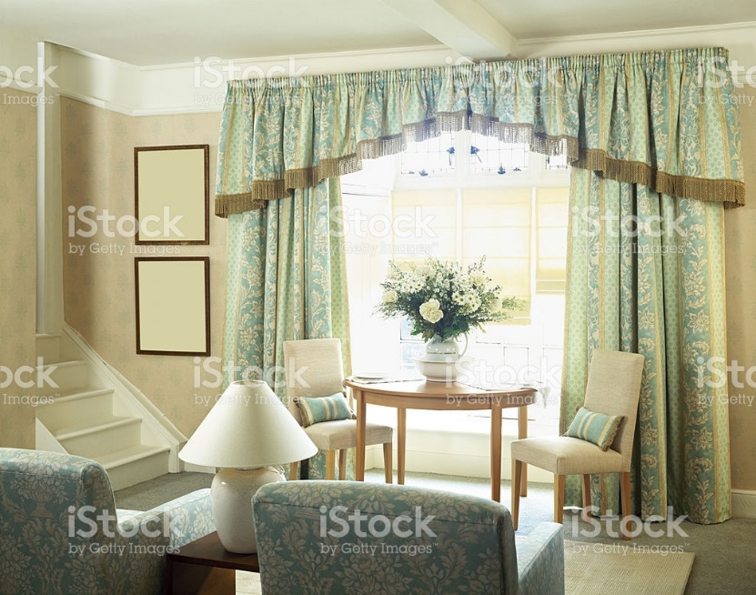

**9. Box pleat**

The box pleat is a tailored pleat style that can be used for all styles of décor. It can be made with each flat box being from about 12” wide to almost any width across the window. Seen often on bed skirts in the larger width, it is adaptable to give a more traditional to more contemporary effect.

Istock id: 481572928

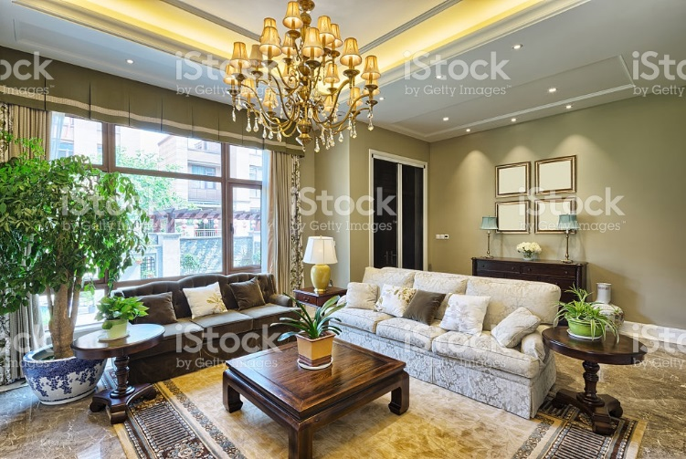

This is a video explaining different pleat types...

[**https://www.youtube.com/watch?v=qEJzPXj7e50**](https://www.youtube.com/watch?v=qEJzPXj7e50)

### Drapery lengths:

Once you select your pleat style of window treatment, you need to determine how long you want the drape to be. There are varying lengths that can be used depending on your style, function and aesthetics you desire.

**Full length:** The most common drapery length is to have the treatment end just slightly above the floor by ½”. A treatment should never be more than 1” off the floor no matter how high you decide to hang it above the window frame. This length can be used for any style of décor.

Istock id: 505951045

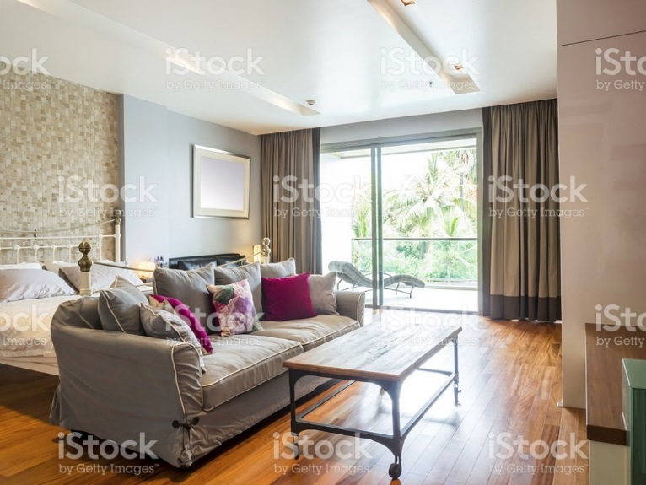

**Trouser length:** This length is a newer style length of treatment and is considered quite chic.

This is when the fabric actually touches the floor by an inch or so in length. It is like a pair of slacks or trousers long enough to break over your shoe or boot. This length can also be used for all styles of décor.

Istock id: 638158146

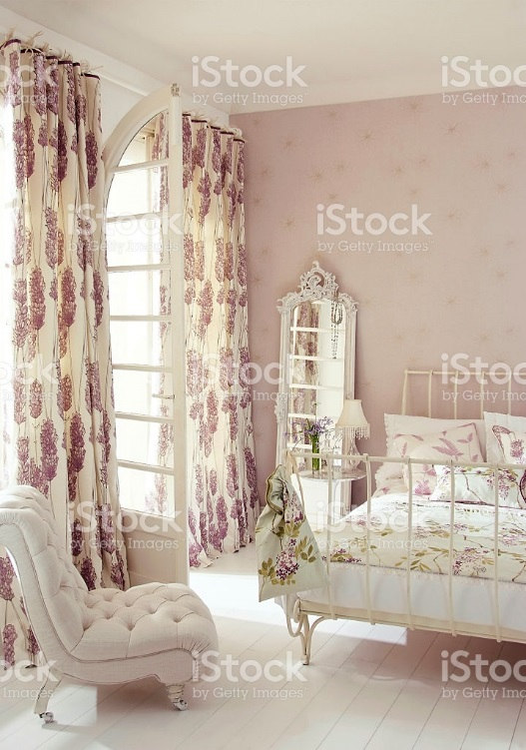

**Puddle length:** The puddle length is a treatment that has several inches laying on the floor in a puddle. This is a stationary treatment only and will not work for any operating or functional used. This style is usually used in more traditional decorating styles creating a lush and romantic effect. This length is not recommended for homes with small children or pets as it requires some maintenance to keep it looking nice.

Istock id: 183776173

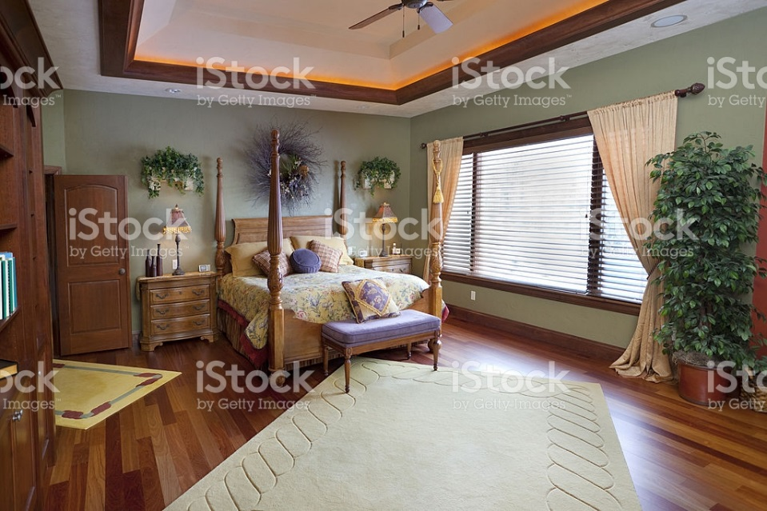

**TIP:**  If you want to use this treatment, get the seamstress to create a draw string pocket in the hem. When vacuuming you can just lift the treatment by the draw string and then drop it down creating a nice puddle that is neat and easy to maintain.

Another consideration when determining drapery length is how high you will hang it above the window trim. The minimum height to hang over the trim is 4 inches but can go as high as up to the ceiling. In the past decade with new homes having higher ceilings the trend is to hang as high as possible in a room. This is an option for those who want to increase the visual look of a ceiling even in homes with 8 foot ceilings. With the trend to big windows and lots of light flowing into a room, also keeping treatments from covering the sides of the window allow more light to flow inside.

By Linda Guthro

Notice how the ceiling and the window looks wider by how the treatment is hung.

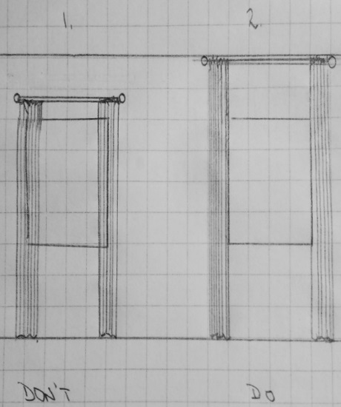

Even if you wish to hang the treatment just above the window frame, consider using more wall space to allow the window to be exposed more rather than being covered by fabric to allow more light into the room.

### Drapery function:

**Stationary drapery:**

Stationary treatments are decorative and do not move. They are meant to look like they are full enough that they can cover the window but are for aesthetic purposes only. This kind of treatment can add softness to a window, make the window appear larger and takes far less fabric to create than functional drapery. Stationary treatments can be used on their own or layered with other textures like blinds, shutters, shades, valances or sheers.

Istock id: 483802693

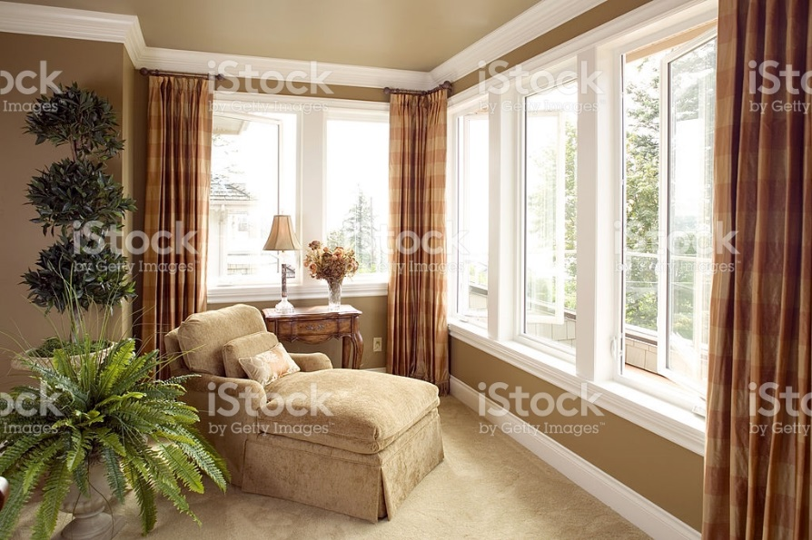

**Operating (Functional) drapery:**

Operating drapery are functional in that they will open and close over the entire window and require considerably more fabric than stationary treatments. In years past windows and whole drapes open fully on the wall and leave the rest of the wall space as wall. Functional drapery move on a rod using pleats with some kind of ring attached to a hook at the back of the treatment.

Istock id: 505951045

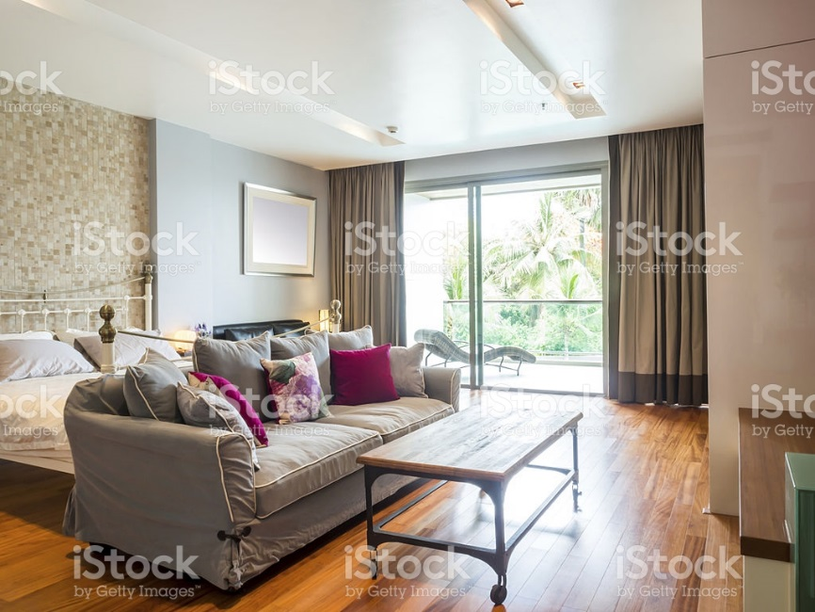

### Window types:

Your text pages 471 – 474 shows many styles of window types. Some require special consideration when planning treatments such as those that open into the room. If these windows are in a home, you need to think of how the treatment can adapt to this function. It is important to always check how the window operates, how deep the window sill is and what kind of treatment will work for the window. Some windows are flush to the wall and others are recessed by 2 inches or more. Each requires thought as to the best treatment to suit the window type. Read over these types to familiarize yourself with some of these options.

I would like to have a discussion or activity that the student can share the kinds of windows they have and if they have a window type that poses a problem for them. Perhaps others can make suggestions to solve the problem

**Interesting note:** I had a client who had California shutters put on all her windows in her home. They looked and functioned great for her for several years. At some point she wanted a new kitchen tap and got one of the new tall arched styles for her sink. To her dismay, she can no longer open her kitchen shutters! She never thought about the function of the window treatment and how the tap now blocks the shutters (that are small doors) from opening to get to the window and she is upset that she can no longer open her window to let in the fresh air. I suggested she remove them and replace with a wood blind that looks close to a shutter but can operate up and down to give her the access she wanted to the window operation.

Custom versus ready-made drapery: Quality and cost differences, pros and cons.

Window treatments are an investment in a home just like furniture and appliances. Depending on budget, each home owner determines what they prefer within their budget. There are choices for ready-made as well as custom treatments and some of the differences are listed here for your comparison.

### Ready-made:

Ready-made treatments are found in many stores in packages that are made to a general length and the customer selects the one closest to their needs.

**Pros:**

* No wait time…can purchase and hang the same day
* Inexpensive
* Good starter treatments

**Cons:**

* Lesser quality fabric
* Standard width and length only
* Fewer selections for individual look
* Often poor draping

Custom made:

Custom made treatments are found in drapery stores or through decorators. Prices range depending on the cost of fabric, design and size of window.

**Pros**:

* Higher quality fabrics that hang well
* Made to fit each window
* Vast selection for an individual look
* Can choose lining requirements

**Cons:**

* Wait time to have made
* Prices range from low to high depending on requirements

There are times and uses for both ready-made and custom that will depend on your needs, budget and level of custom in a home. As decorators, custom treatments offer such a wide variety, quality and appearance it is the go-to way to offer a client a one of a kind look that cannot be found at the nearest store or in every home in the neighbourhood.

**Interesting note:**

There was a student who purchased ready-made silk drapery at a store in Toronto for $800/pair. They had a lining, but it was very poor quality. He asked if they could be replaced with a lining that would protect his silk from the sun. This meant that the entire treatment would have to be re-made custom for him. It ended up costing him more to do the proper lining than if he had purchased them custom to begin with. This was a real eye opener for him as he thought custom would be much more costly than ready-made.

While you can certainly purchase a drapery panel for a beginning price of around $20-$50 ready-made, it does not mean that all ready-made treatments are always less expensive. Be aware when shopping and do your research.

One thing to keep in mind…your level of drapery should match the level of custom you have in your home. If you have invested in good quality furniture that will last you for a long time, then you should do the same for your window treatments. When comparing the look between a ready-made and custom made treatment there is a vast difference in the look, feel and quality that makes the investment worthwhile.

Something to think about…I mentioned earlier that the trend is to hang high for drapery and this is also a practical idea as well. If you hang your drapery from ceiling to floor or high above the window trim, it means that the treatment you invested in will adapt to a new residence more easily and not just fit the window it is on now. Windows all have varying heights but walls are rather standard, so if you fit your treatment to the wall size, you have more room to work with if you move and can take your investment treatment with you.

## Conclusion:

There are endless looks that can be achieved in window treatments to create a one of a kind look for every home. We are fortunate to have so many to choose from! It can also be overwhelming to decide what is right for an individual. Decorators are always looking for the latest trends, fabrics, styles and looks to be able to offer our clients. You can do the same by checking out magazines, stores and home shows for the latest in this exciting topic.

********************* End of instructional content *************************